LOOKING to 2023
A CHALLENGE TO PRAY AND GIVE

Champions for Congo News - December 19, 2022

TREASURES IN HEAVEN
As we close out 2022, I am reflecting on Ephesians 2:10. “For we are his workmanship, created in Christ Jesus for good works, which God prepared beforehand, that we should walk in them.” We are saved by grace to be who we were created to be and live life with a purpose and meaning.

Champions for Congo is making a difference and you can be a partner in this vital, transforming healthcare ministry. First and foremost, we need prayer partners who will support us daily and fervently in prayer. As you commit this year to be a partner, you will be informed as to our needs and progress. Secondly, there are opportunities to be an investing partner in our mission.

INVESTING IN 2023
The beauty and blessing of being saved by grace is that we discover that LIFE HAS MEANING AND PURPOSE in new ways, beyond anything we could imagine.

This reality has brought us to THINK BIG FOR DEACONESS NUNDU HOSPITAL – ALL FOR THE PURPOSE OF BRINGING HOPE.

The realities of South Kivu, the region served by Deaconess Nundu hospital, invite God’s Kingdom to come here on earth - healing and hope, young people taking charge of their future with purpose and meaning. What will healing and hope look like at Nundu in 2023? We are thinking big. How might you be a partner with purpose and meaning?

The vision for 2023 is to fund the following projects for a total of $192,000. Would you consider supporting one of these projects in whatever amount you are able:

- Medication Fund ($10,000) provides medications. Our patients, young and old, are impacted by parasitic and infectious diseases that are debilitating and life threatening. Surgery for life threatening emergencies requires a variety of medications.
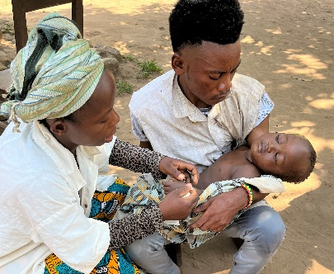
URGENT CARE REQUIING MEDICATIONS

- Patient Care Fund ($10,000) enables the hospital to treat all, regardless of ability to pay. Endemic poverty makes it difficult if not impossible for many people to pay for their hospital care, often causing them to delay treatment. $10 saves two lives (mother and baby). $25 treats a child with malaria.

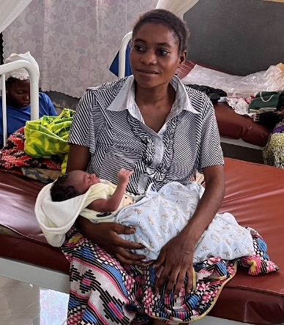
NEWBORN AND MOTHER

- Nutrition Supplement Program ($7200) gives hope to impoverished families struggling to provide for their children. At risk or malnourished children receive porridge made from corn, sorghum, and soybeans, all locally grown and prepared. We partner with International Child Care Ministries in an agricultural project which has made this possible.

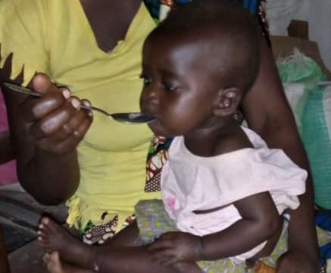
LIFE GIVING PORRIDGE

- Salary Support ($58,600) enables doctors, nurses, administrative personnel, and support staff to serve at NDH. The monthly income for the average nurse at Nundu is $100 to 125.
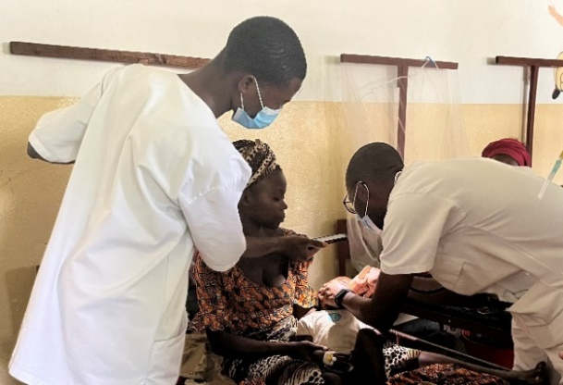
Dr. MARX WITH A NURSE EXAMINS A CHILD

- Medical equipment Fund ($60,000) will upgrade the surgery department for a more active surgery service.
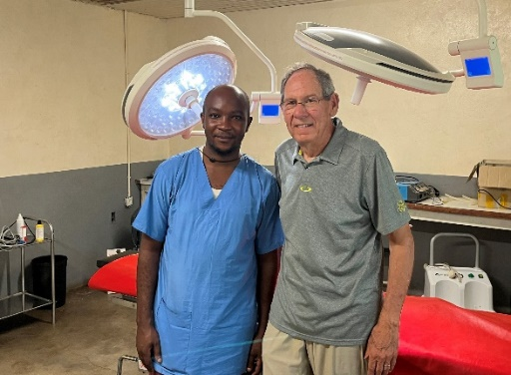
NURSE MANENO AND TIM KRATZER IN SURGERY #1 ALREADY EQUIPPED
Surgery lamp for the second operating room - $6500
Energy efficient autoclave - $13,500
X-ray - $30,000
New surgical instruments - $10,000

- Hospital ambulance

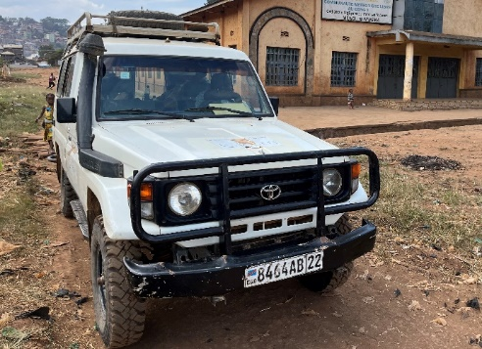
TOYOTA LANDCRUISER
The hospital does not have a vehicle for ambulance runs, transport of medications and supplies, visiting health centers, or meeting guests. ($50,000 new and $20,000 used).
- Nundu school of nursing ($7200) is training nurses for our future.
- Hadduck House renovation ($15,000) will provide a guest house and or staff housing.
MAKING A DIFFERENCE
Your gift big or small will make a difference. Your prayers make a difference. Use this list as a prayer calendar for each week. Eight projects, seven days.

Champions for Congo is making a difference by supporting the following projects:
Medication Fund $12,000
Patient Care Fund for families who are unable to pay hospital fees. $12,000
Nutrition Program, especially important when families have limited resources. $7,200
Salary Supplements $58,600
Medical Equipment Fund $60,000
Hospital Ambulance (used) $20,000
Nundu School of Nursing $7200
Hadduck House Renovation $15,000
TOTAL $192,000
Total Pledged to Date $84,500
Remaining to Reach our Goal $107,500

We invite your prayer support and commitment to these projects. Thanks to those who have already made pledges.

You can give on this website: (GIVE ONLINE)
or you can send a check to:
CAHO, PO Box 580, Spring Arbor, MI 49283
Also, please consider sharing this information with friends who may want to pray and give.

If you want more information or have questions, please e-mail timothykratzer@hotmail.com or normwetterau@aol.com.
Give us a call. We would welcome the opportunity to tell you more about what it means to be a Champion for Congo.
- Tim Kratzer (520) 390-3402
- Norm Wetterau (585) 705-8811

Merry Christmas and Happy New Year,
Tim Kratzer

