BUTTERFIELD PARTNERS WITH DNH TO EXPAND SOLAR - A LIGHT IN A DARK PLACE
We have just received the good news that the Butterfield Memorial Foundation is partnering with Deaconess Nundu Hospital to upgrade and expand its solar installation. Could you imagine surgery, an intensive care unit, 24-nursing care, maternity and neonatal unit without reliable electricity? The reality is that there was no sustainable electricity or running water for this 110-bed hospital until the first solar power system was installed in 2018. The Butterfield Memorial Foundation joined us in assisting in funding that first installation. BMF again is partnering with DNH in providing a generous $200,000 grant. The total cost of this project will be $307,027. Beyond the $200,000, we will support this project with contributions from individual donors. We invite you to join this project as we currently need an additional $12,000.
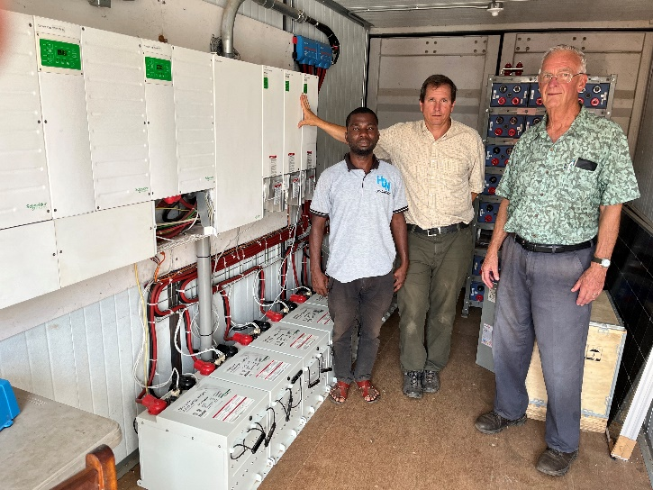
This 17 KVA system will be expanded to 51 KVA.
The impact of having electricity 24-7 on the quality of medical care has been significant. Surgery can be performed day or night. Intensive care can be delivered at a higher level, including the provision of supplemental oxygen. However, the current system has only been providing about two-thirds of the energy needed. A diesel generator makes up the difference, consuming about 1000 liters of fuel per month at a cost of about $1200. At today’s fuel prices and factoring in maintenance, the cost of operating the current system is about $18,000 per year.
The current system, installed in 2018 with a capacity 17 KVA and upgraded in 2021 with the addition of lithium batteries, requires expansion to support current operations as well as provide for future needs. Plans are in place to purchase an X-ray, add a larger autoclave required for our growing surgery program, and expand laboratory services. An energy audit has documented current energy needs as well as projected future requirements. Based on this study and monitoring the system as it is currently functioning, a solar system has been designed which will triple the capacity of the present system to 51 KVA, providing affordable and sustainable energy for the DNH campus for the foreseeable future.

International Technical Electric and Construction (I-TEC) will assemble the system in Montoursville, PA beginning in February. A team of I-TEC volunteers will then travel to Nundu to oversee the installation the summer of 2023. Michael Fisher with I-TEC currently monitors the system by an internet connection and will continue to do so after the installation is completed. Tim and Connie Kratzer will be on site at Nundu to host the installation team.
DNH is a center for hope and healing, providing healthcare that transforms, a light in the darkness. A reliable source of power provides an environment where an underserved population is treated with respect and dignity. That Deaconess Nundu Hospital remains a beacon of God's light and healing despite enormous challenges is a testimony to the resilience and dedication of the staff along with God's provision. Some remarkable projects have included a pediatric ward building completed in 2016 and a maternity built in 2017. Recent successes in these projects and the rebuilding of the hospital infrastructure damaged by war make this an opportune time to invest in the future.
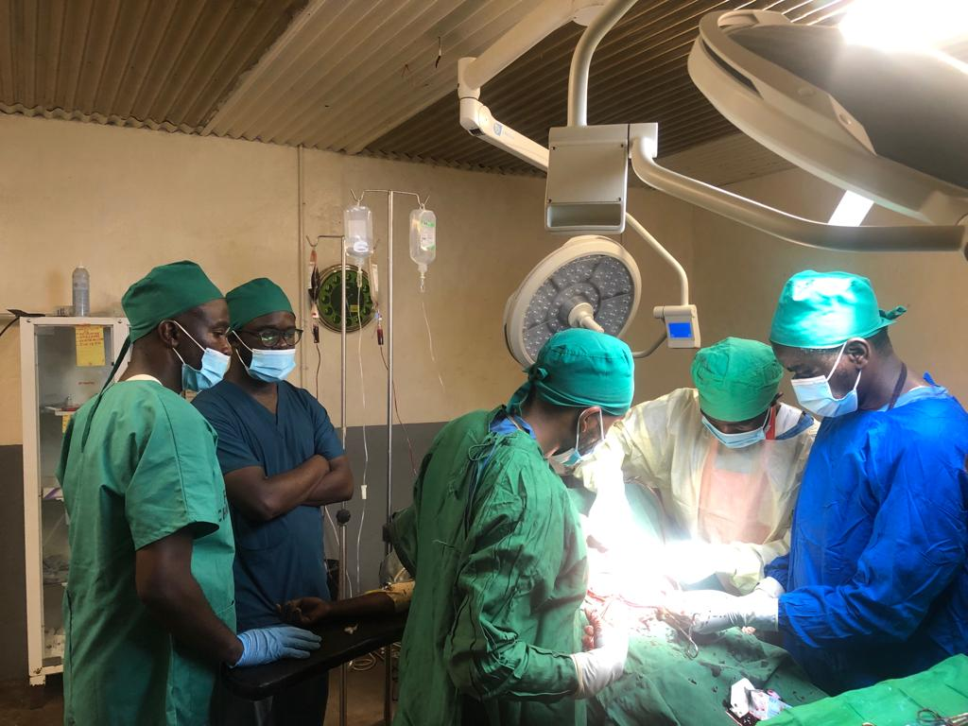
Surgery suite Deaconess Nundu Hospital
With this investment in the hospital’s infrastructure, DNH will continue to be a center of excellence serving as the hospital of reference for 21 healthcare centers in the Nundu Rural Health Zone. As recently reported, Dr. Byamungu is just now completing his surgery training and will be joining the staff soon. Dr. Luc is in his second year of OB-Gyn residency. Complicated cases, surgical and obstetrical, will receive the best of care as patients are referred to the hospital from these centers.
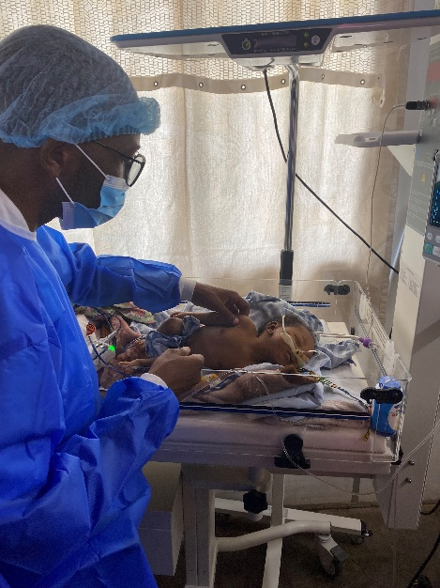
Dr. Marx caring for a newborn, NICU
The pediatric service has already been impacted by the NICU established by Dr. Marx, made possible by the present solar plant installed in 2018. Having an expanded reliable energy source will allow the hospital to grow and thrive. The future is bright at Nundu thanks to the Butterfield Memorial Foundation and our individual donors. We invite you to join in shining a light, a beacon of hope, in the darkness.
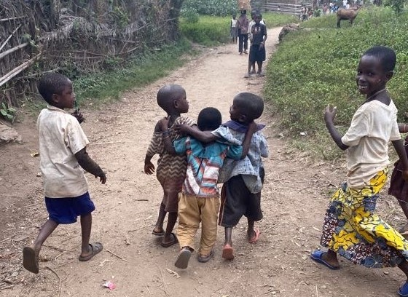
A Hope and a Future

