GIVING THANKS FOR GOD’S PROVISION
Champions for Congo News – November 2022
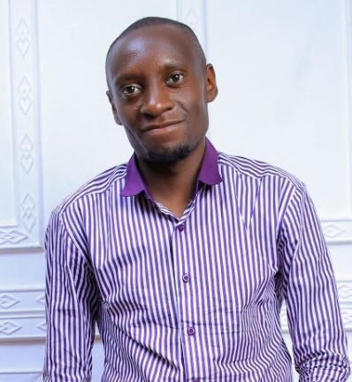
Dr. Byamungu, Graduating November 12, 2022
Dr. BYAMUNGU TO JOIN DNH STAFF
Dr. BYAMUNGU KAGENDEREZO Pahari, is completing a surgery residency at Kampala International University (KIU) in November. He was born in December of 1988 and lived as a youth in Lusenda just 6 miles south of Nundu. (See his story following.)
The son of a Free Methodist pastor, he himself is an active member of the Free Methodist Church. He speaks more than six languages including French, Swahili and English. After completing Senior Six at the Nundu Secondary School, he became active in teaching children the Good News. In 2009 he joined Child Evangelism Fellowship (CEF). He went on to study at the CEF Institute in Nairobi, Kenya to become a trainer of CEF teachers, all with the mission of empowering churches to instruct the children in their communities.
In 2010 he went on to enroll in the school of medicine in Bukavu located in the Democratic Republic of the Congo. Byamungu had dropped out of school due to lack of finances, but after prayer and fasting, support started coming in. Over the years the Lord continued to provide support in answer to prayer. After completing a Bachelor of Medicine and Surgery, he did one year of internship in Bukavu. He then joined the Deaconess Nundu Hospital in a volunteer capacity, serving for two years. During that same period, he also served as a lecturer at Nundu School of Nursing.

In January 2019, he joined a Master of Medicine in General surgery at Kampala International University, Uganda. He feels called to provide surgical care to the underserved population in the rural area around Nundu and beyond. He is not only committed to providing surgical care of the highest quality but also to empowering churches in child evangelism.
Dr. Byamungu describes his surgical training as preparing him in a wide variety of procedures. Even before his residency he was performing C-sections, appendectomies, herniorrhaphies and other minor operations. During his training from January 2019 to August 2022 he assisted in hundreds of different surgical procedures, and he himself performed more than 200 surgeries. He also enjoyed teaching students under his supervision.
Dr. Byamungu is now returning to Deaconess Nundu Hospital in keeping with his call to serve the underserved. During his training he returned to Deaconess Nundu Hospital at his own expense on a regular basis to perform surgery and better understand how to improve the surgical service. His commitment to teaching has allowed the staff to learn surgical procedures and together improve the outcome for surgical patients.
He has been supported in his medical school and surgery residency by the generous support of several Champions. Together with Dr. Byamungu, his wife and family, we celebrate the successful completion of his surgical training and his commitment to serve.
PRAYERS AND FINANCIAL SUPPORT ARE NEEDED
The poverty of South Kivu, where Nundu is located, could be overwhelming, but the people have a quiet resolve to champion change. The Free Methodist Church of the DRC is inviting all who will to join them in their journey, assisting in whatever way possible. Contributions to help with this important work may be given through the Central Africa Healthcare Organization (CAHO). (See details below.)
Champions for Congo is making a difference by supporting the following projects:
Medication Fund $1000/mo
Patient Care Fund for families who are unable to pay hospital fees. $1000/mo
Nutritional Supplements, especially important when families have limited resources. $1000/mo
Salary Supplements $2400/mo
Maintenance Team Support $825/mo
Diesel fuel to supplement solar power $600/mo
HOW CAN YOU GET INVOLVED?
Funds for the Patient Care Fund are urgently needed. Here is how you can impact patient care as you sacrificially give.

- $10 saves 2 lives (mother and child). (Cost of a Starbucks or a lunch)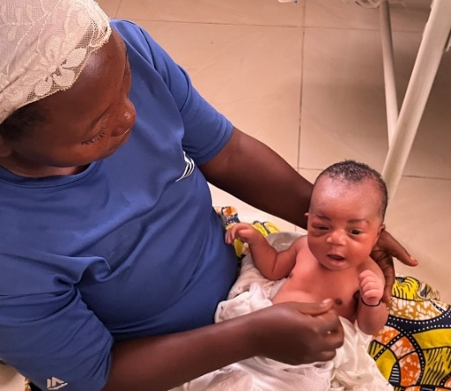

- $25 saves the life of a child with malaria. (Family dinner out at a fast-food restaurant)
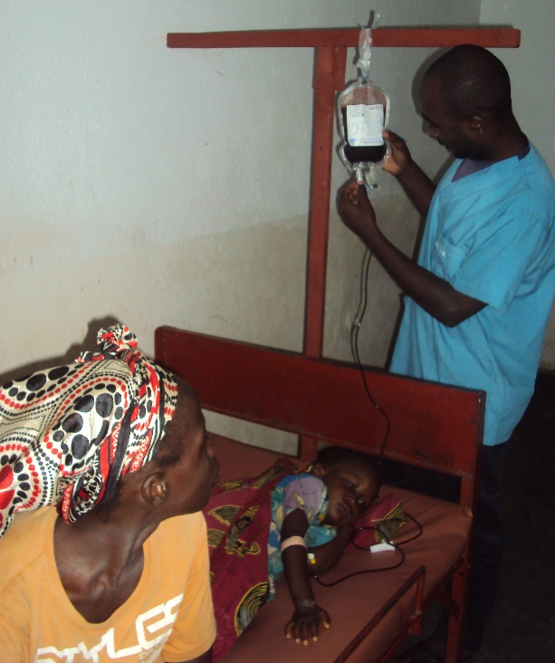
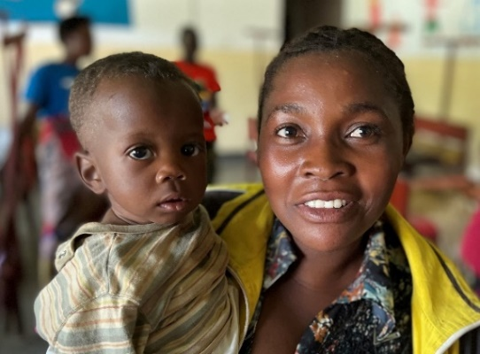

- $55 covers the cost of a C-section or major surgery. (Dinner for two, Olive Garden)
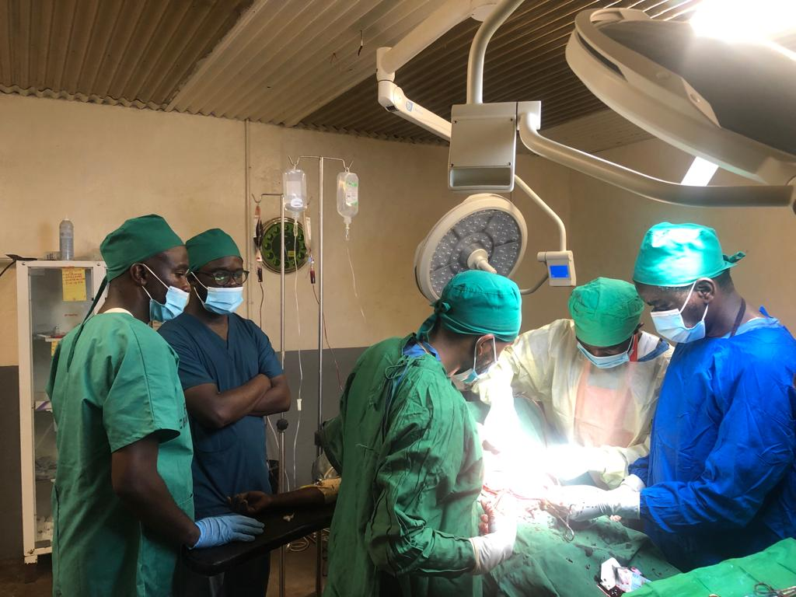
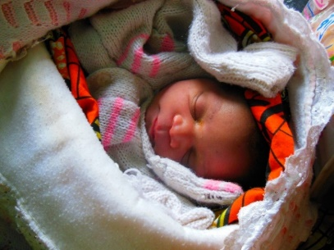

THANK YOU FOR YOUR SUPPORT!
In our August newsletter we described a system of healthcare which includes 53 healthcare ministries established and directed by the Free Methodist Church of the DRC. Dr. Byamungu was blessed to grow up in a village, Lusenda, where there was access to a health center.
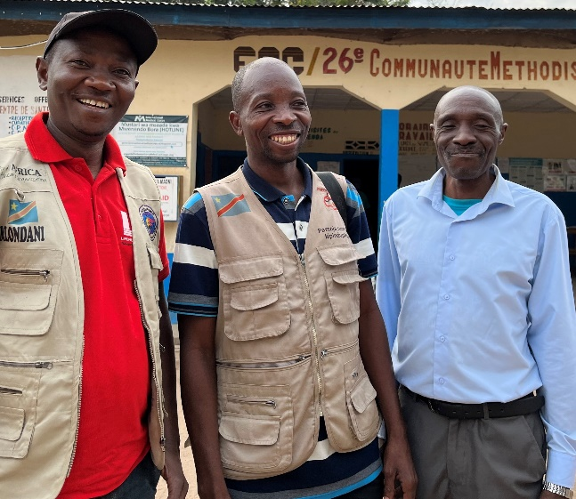
The father of Dr. Byamungu, Pastor Kagende, on the right, standing in front of the Lusenda Health Center
These centers of healing will survive and thrive as local initiative is encouraged, a new generation of leaders are trained, and partnerships are formed. Dr. Byamungu is a product of our schools and scholarship support. Each one of you is a valuable partner, as you pray and consider how you might give. The church has invited us to join them as partners in their journey. Together we are experiencing Healthcare that Transforms.
As you give, you are a part of this journey of transformation, providing hope and a future. Imagine the lives that will be saved for every $100 given - ten new borns off to a healthy start, four children treated for malaria, two patients recovered from major surgeries.

How will the hospital support a surgeon? We welcome pledges to assist with Dr. Byamungu’s salary and gifts to cover the cost of surgical instruments which are urgently needed.
Give online at www.gocaho.org or by mail to Central Africa Healthcare Organization, 8050 Spring Arbor Road, P.O. Box 580, Spring Arbor, MI 49283.
You can also contribute through the Champions for Congo website at www.congohealth.org.
We will keep you informed as your gifts impact the cost of patient care and assist Dr. Byamungu in his surgical practice at Deaconess Nundu Hospital.
If you would like additional information, contact me by email, timothykratzer@hotmail.com or by phone at 520 390 3402. You can also contact Norm Wetterau at 585 705 8811.

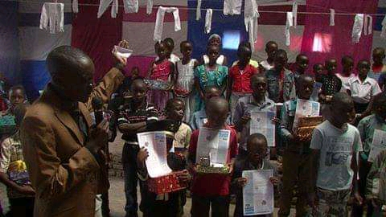
Dr. Byamungu celebrating Christmas with children in a local Free Methodist Church in Mushununu-Panzi, Bukavu in 2014 while in medical school.
Tim Kratzer November 3, 2022

POST-SCRIPT: HIS STORY IN HIS OWN WORDS
Dr. Byamungu

I was born on the way to the health center in the rural territory of Mwenga, where there was a Free Methodist Church. My mother would walk for many hours to reach a nearby health center. When her labor started, she had to walk for hours before she delivered me on her way to the health center. She was assisted by my grandma. She couldn't reach the health facility as she intended because of the distance and there was neither car nor motorcycle.

Madame Alice Mathewson was the one who taught me English. She also taught me the Bible and she took me into their home at Nundu to stay together with them (Randy and Alice Matthewson) for months.

I have included a picture taken in May 2022 of my family ( Father, Mother and elder brother) and me coming to Nundu to thank Dr McGee and the Mathewsons for supporting me in school. From left to right is my elder brother, Bwana Matthewson, Madame Alice, Dr McGee, my father, my mother, me, and Pastor Sam Kirui.

My father's name is Kagenderezo Munonia Kabandula but commonly called Pastor Kagende. My Mother is Clementine Asaku Kagende.

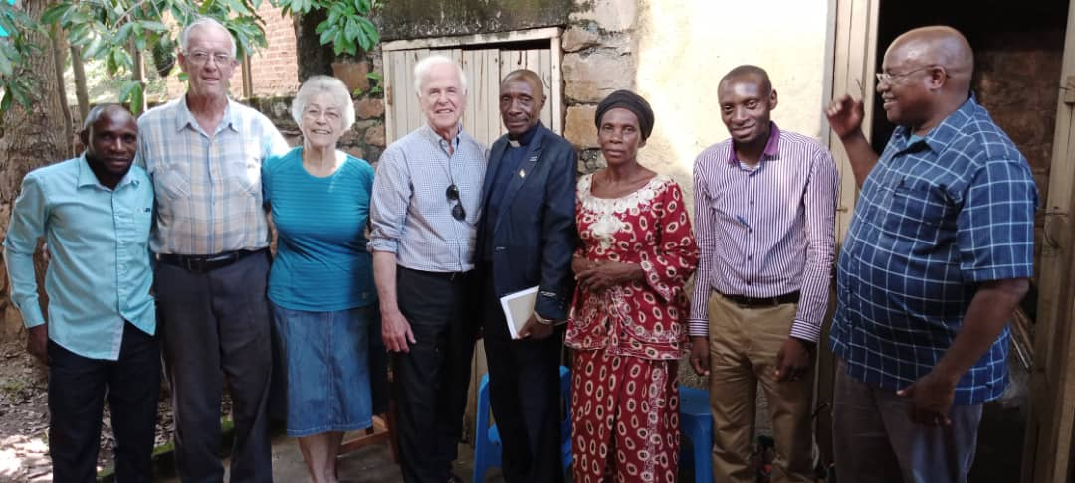

(Dr. Byamungu wishes to thank the people who supported him through medical school and surgery residency, including Randy and Alice Matthewson, Dr. Mike and Leann McGee, Wayne Beitzel, and Aaron Hamilton.)

