KRATZER CONGO MISSION
Champions for Congo News – September 1, 2022
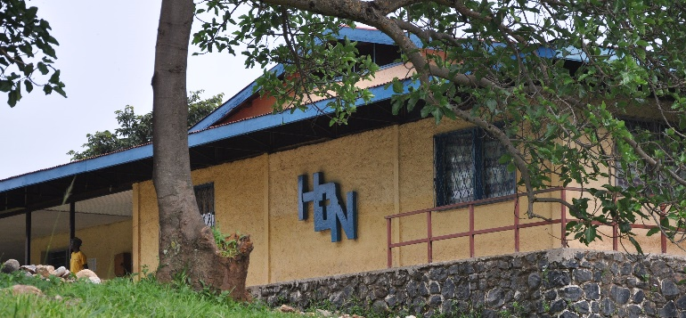
Deaconess Nundu Hospital

SHARING OUR JOURNEY TO THE CONGO
In June my son Ken, two of his daughters, Lupita and Savannah, and I traveled to the Democratic Republic of Congo. What we experienced as we witnessed the work of the Free Methodist Church in the Congo was transforming. We toured Deaconess Nundu Hospital, visited the Nundu School of Nursing, learned about the various healthcare ministries of the Church, experienced International Child Care Ministries (ICCM) of the DRC and met with Bishop Lubunga.
As promised in our previous newsletter, we have more highlights to share, including the ICCM agricultural project, our visit to the Linda Stryker Academy, the solar expansion project, our trip to Bukavu, the provincial capital of South Kivu, and opportunities for involvement in the future of the Free Methodist Church in the Congo.

The ICCM agricultural project was a highlight early on in our visit to Nundu. Rev Luk established and oversees what is known as a Women’s Farming and Savings Program (WFSP). In the subsistence economy of South Kivu where the per capita income is estimated to be $1/day, women bear the burden of feeding the family, educating their children and paying for healthcare. Women tend to neglect their own health, even when they are pregnant, with dire consequences.
WFPS is dedicated to empowering women by introducing them to improved methods of farming. They learn how to grow different crops, including soybeans, corn and sorghum. Women are mentored, as they come to the farm for a three-month period, by an agronomist. They receive instruction in marketing the excess harvest and putting their earnings in a savings account.
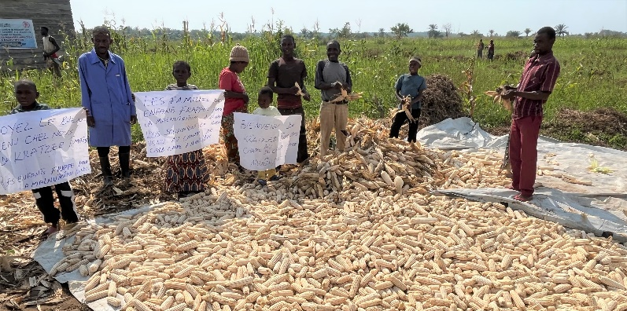
Children, mothers, and staff welcome us to the corn harvest
This program became a reality for us when we were greeted by students, family and technicians. We learned from Rev. Luk that more than 12 acres had been put into cultivation, with another 8 acres ready for cultivation. We witnessed an abundant harvest of soybeans and corn. Ready for harvest was a field of sorghum.
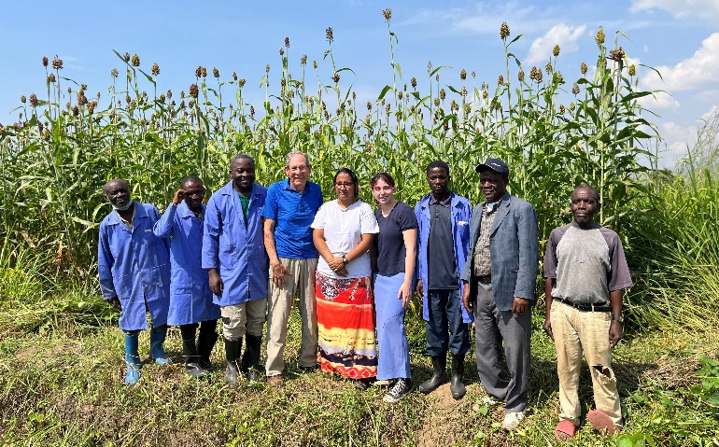
Sorghum ready for harvest with agronomist and his team
This produce is blended into a high energy, protein rich porridge which is sold to the Deaconess Nundu Hospital l as a nutritional supplement for malnourished children.
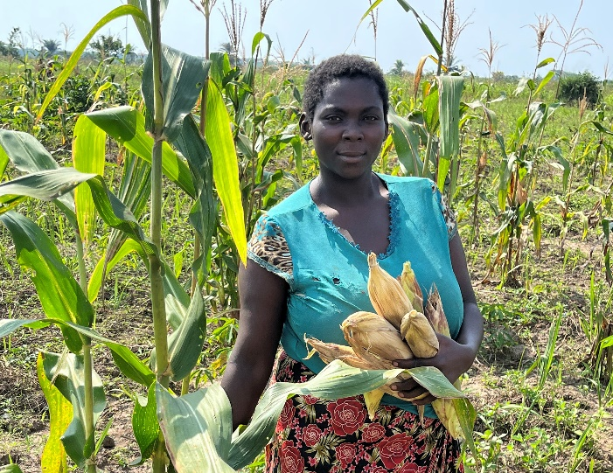
A student reaps the harvest
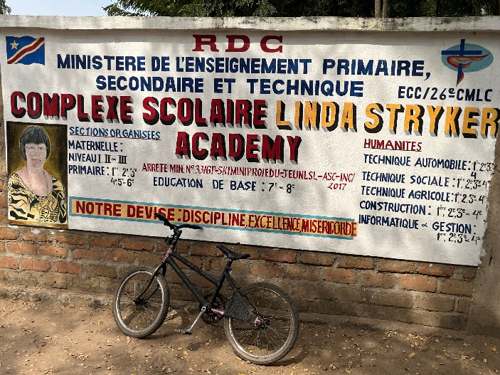
A truly remarkable highlight of our visit was seeing the Linda Stryker Academy located on the Mshimbakye Station three hours south of Nundu, but only a distance of 30 miles. The academy was established in 2017 in respecting a request by Linda that a school would be established which would maintain high academic standards. The school now has 256 students enrolled and a staff of 28. Instruction is in French, using a more interactive approach rather than rote memory. We were honored by a program which highlighted the students, their energy and talent. There is so much more to be said about this school and Linda Stryker that I am including an ICCM article from October 2017 (attached separately).
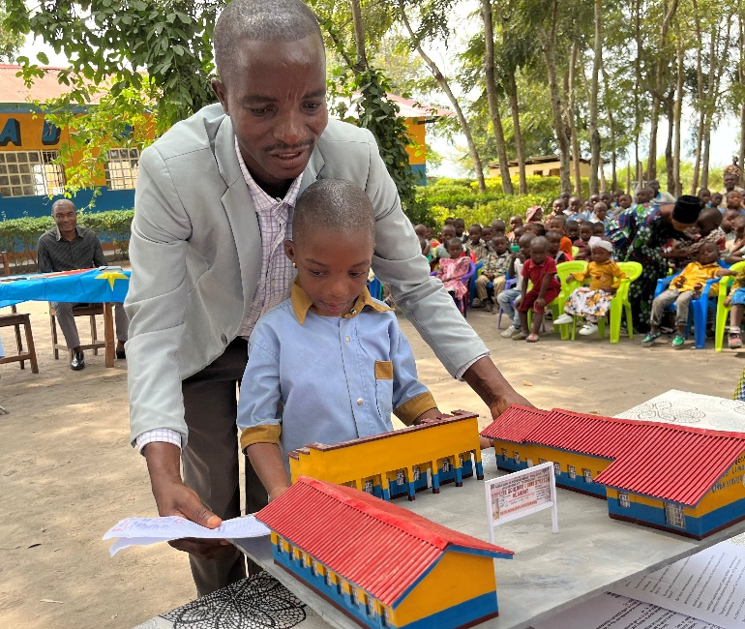
A model of the LSA presented to us as a gift
The school was started in response to a gift from the estate of Linda Stryker. Ongoing gifts have funded additional development of the school, and students are supported by ICCM child sponsorship, covering the operational costs. While visiting the school I met the students Connie and I sponsor. I am not sure what they thought of me, but I do know that they are receiving an education that gives them hope and a future. I also know that I care about them and the other students who are also being sponsored.
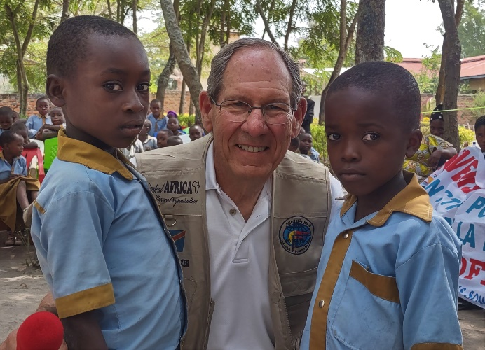
Eangano Bokyo (age 10) and Dieudonne Jacque (age 8)
All this, an agricultural project and a school, brings to mind some important questions. What we have seen is compelling, giving witness to a vital church dealing with unlimited humanitarian need. Ken observed. “We can be present and give nothing or give all that we have and not be present.” What is the church hoping for? They want us to be present but also share whatever resources we might have. When and for what periods of time should we be present? How can we be involved in a productive way? What will our legacy be? Who might benefit from that legacy? We can best be prepared to respond to the needs and expectations of the church as we are physically present, much like the Matthewsons have been. (We shared some of their story in our previous newsletter.) We can also be generous in sharing of our resources now and in the financial legacy we leave after our passing, much like Linda Stryker did.
Now let’s head 140 miles north to Bukavu, the provincial capital of South Kivu. The distance is not far, but it takes us all day to get there, over hot and dusty roads. As we start to climb the mountain road, there is a security check which thankfully we pass. As we continue to climb, the temperature gradually moderates but the dust continues. We arrive in the city at dusk, the roads teaming with cars, trucks, motorcycles, and people all mixed together. In this city is located the office of Bishop Lubunga, FM churches, schools, and a hospital. We are also going to see the ICCM sponsored mill.
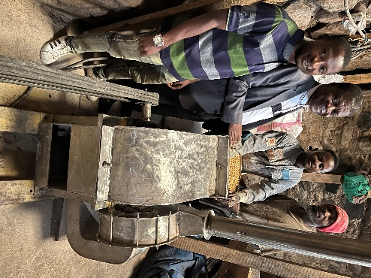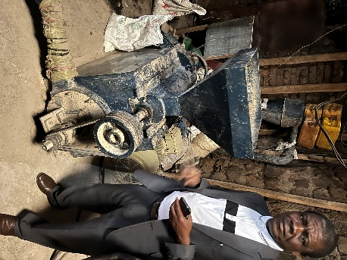
ICCM sponsored mill in Bukavu
The city of Bukavu is a buzz of activity – retail shops, car repair and sales, gas stations, small manufacturing, multistory apartment buildings and newly constructed hotels. There are also churches, schools, clinics, and hospitals. This is a city unrecognizable from what I remember. Mixed in with the new are those who have come in from their villages to find work or escape civil unrest. They find lodging in simple dwellings with limited services and minimal hygiene. Not one space on the hills going down to lake Kivu seems to be empty.
In the middle of this busy city is the ICCM sponsored mill managed by Rev. Luk. Workers grind soybeans, corn and sorghum and produce the porridge that will be sold in the city and down country at Nundu. The product is imported, but the hope is that in the future there will be adequate supplies from farms in the DRC. This is microenterprise taking one step at a time.
What does a small farm, a Linda Stryker Academy and a grinding mill have to do with Deaconess Nundu Hospital and healthcare? Remember that in our last newsletter we described a system of healthcare which includes 53 healthcare ministries established and directed by the Free Methodist Church of the DRC. These centers of healing will only survive and thrive as local initiative is encouraged, a new generation of leaders are trained, and partnerships are formed. The church has invited us to join them as partners in their journey. Together we are experiencing Healthcare that Transforms. You will be learning more about that journey, partnership, and transformation in the future. This reminds me, I promised to give updates on the solar expansion project which I will be doing soon.
The poverty of South Kivu, where Nundu is located, could be overwhelming, but the people have a quiet resolve to champion change. The Free Methodist Church of the DRC is inviting all who will to join them in their journey, assisting in whatever way possible. Contributions to help with this important work may be given through the Central Africa Healthcare Organization (CAHO) online at www.gocaho.org or by mail to Central Africa Healthcare Organization, 8050 Spring Arbor Road, P.O. Box 580, Spring Arbor, MI 49283. You can also contribute through the Champions for Congo website at www.congohealth.org.
Champions for Congo is making a difference by supporting the following projects:
Medication Fund $1000/mo
Patient Care Fund for families who are unable to pay hospital fees. $1000/mo
Nutritional Supplements, especially important when families have limited resources. $1000/mo
Salary Supplements $2400/mo
Maintenance Team Support $825/mo
Diesel fuel to supplement solar power $600/mo
Projects which urgently need support include…the Patient Care Fund and Nutritional Supplements.
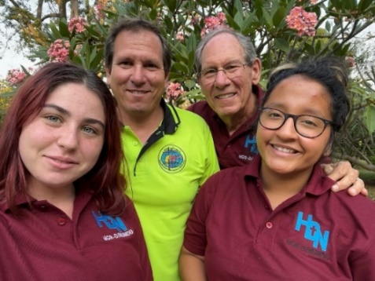
We, Savannah, Ken, Tim and Lupita, thank you for your prayers. Our mission trip was transforming.

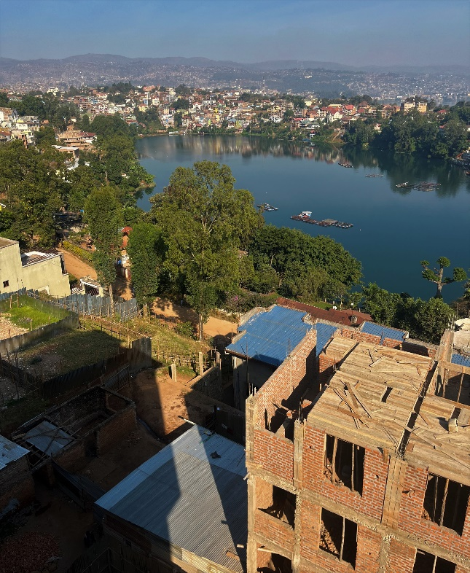
Bukavu, a growing and thriving city of one million

